# FlyNet Hardware

The components for the FlyNet system (as of the Fall 2015 semester) can be split into two categories, these being the quadrotor structure and the onboard electronics. The quadcopter structure can be broken down further into the frame itself and the additions of custom created landing gear and propeller guards. The electronics consist of all of the sensors, actuators, and computers that make the quadcopter fly autonomously.

## Quadcopter Frame

The structure of the quadcopter is essential as without it, there would be no platform to support the sensors and no way to move throughout the environment. The custom additions (landing gear and propeller guards) will be covered in the following subsection. The frame of the quadcopter was selected as the AlienCopter Bee 430mm, shown in Figure 1. Initially this platform was provided to the FlyNet team from RECUV. This allowed initial testing to begin and members of the team to become comfortable with flying quadcopters. Further investigation was needed however to prove the use of this frame.

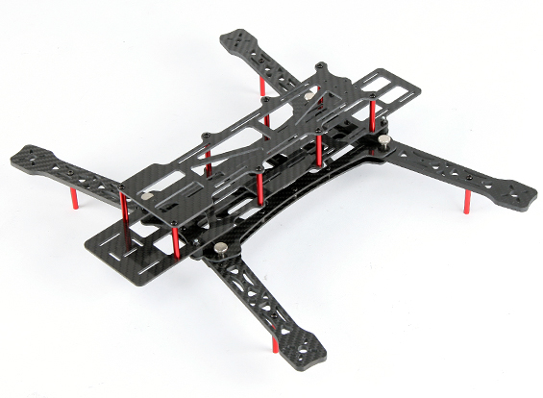

Figure 1: AlienCopter Bee 430mm Frame

A trade study was performed between different off the shelf frames. Additional frames were considered…

Table 1: Quadcopter Frame Trade Study

|  |  |  |  |  |  |
| --- | --- | --- | --- | --- | --- |
|  | Grading Weight | AlienCopter Bee |  |  |  |
| Frame Size |  |  |  |  |  |
| Available Space |  |  |  |  |  |
| Weight |  |  |  |  |  |
|  |  |  |  |  |  |

## Custom Constructed Components

There are a total of four different components that were custom built for the Terminator quadcopter. These include the propeller guards and landing gear as well as custom mounting hardware for the DJI Guidance sensor and FLiR Lepton camera.

Figure 2 shows the propeller guards and landing gear mounted on the quadcopter. Landing gear were created using 3 inch diameter PVC piping. Two 1 inch rings were cut from the piping and then cut in half. One piece was zip tied to each of the quadcopter arms. PVC piping was using to help with less than soft landings. They act as springs to help and dampen the landing.

The propeller guards were created using carbon fiber rods and a hula hoop. The T-shaped carbon fiber arms were made by cutting 5.5 inch long pieces placed at the end of 10.5 inch long rods. The longer rods were filed at their ends to mesh with the circular rods. The two were then tapped and connected using hot glue. The rods were connected to the quadcopter frame in two parts. A hole was drilled 4.25 inches from the end of the long rod and a M3 screw went through that into the base of the motor. Zip ties were then used to secure the rod to the arm. The hula hoop was then cut into three equal pieces, approximately 32 inches in length each. Holes were drilled in the hula hoop pieces to fit over and around the T-shaped arms. Requirements state that the quadcopter must be able to fit through a standard 36 inch door frame. Fully assembled, as shown in Figure 2, the quadcopter measures 30 x 28 x 8 inches, leaving 4 inches on each side of the quadcopter between itself and the doorframe. Manual flight testing proved that it is possible for the quadcopter to fly through this size doorframe. Simulations and flight testing has shown that the controllers can hold the quadcopter within a blank tolerance. The propeller guards were also designed in such a way that the quadcopter will be able to bounce off the doorframe, like a bumper car.

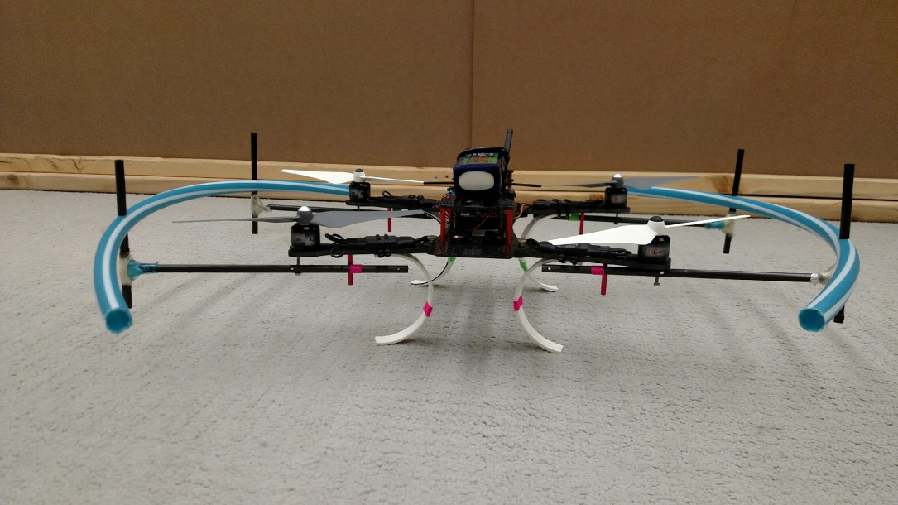

**28 inches**

**Propeller Guards**

**Landing Gear**

Figure 2: Custom propeller guards and landing gear

A single circular ring style guard was not used due to the use of the FLiR camera on the front of the vehicle. Originally, before the acquisition of the DJI Guidance sensor, a single RGBD camera was going to be used for the visual imagery for the SLAM calculation. Also using only two-thirds of the hula hoop reduced the mass of the propeller guard system.

Custom mounting hardware was also designed to mount the DJI Guidance Sensor to the quadcopter. Figure 3 shows an isometric view of the Guidance sensor and it’s provided mounting hardware. However, this system is designed to fit with the DJI M100 Matrice quadcopter and the mounting holes do not line up with the AlienCopter Bee frame.

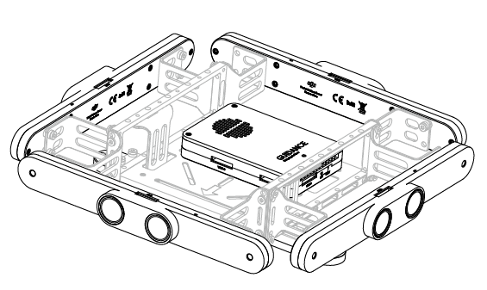

**Ultrasonics**

**Stereo Camera Pair**

**Holes for Custom Guidance Mount**

Figure 3: Isometric view of DJI Guidance Sensor

To accomplish this, a simple mounting bar, shown in Figure 4, was created in SolidWorks and cut out of a 3/16 inch piece of acrylic using a laser cutter. The two inner holes mount directly to the AlienCopter Bee frame and the two outer holes attach to the Guidance sensor.

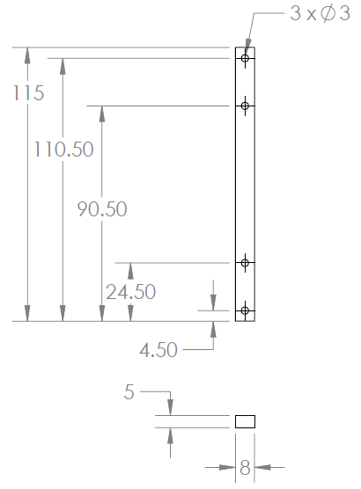

Figure 4: Guidance Mount Drawing, dimensions in mm

The final custom created piece is the mount for the FLiR camera. This was done by….

## Mass Budget

Using all of the aforementioned components a mass budget was created for the Terminator quadcopter. The mass budget is shown in Table 2. Note most entries are broken down in to the various components with a few exceptions such as the ODROID and Guidance sensor. These items include attached items such as the Wi-Fi dongle and mounting hardware. The total system without any additional payload weighs 2.37 kg.

Table 2: Terminator Quadcopter System Mass Budget

|  |  |  |
| --- | --- | --- |
| **Component** | **Qty** | **Mass (each) [g]** |
| AlienCopter Bee Frame | 1 | 303.0 |
| Custom Landing Gear | 4 | 22.5 |
| Custom Propeller Guards | 2 | 123.0 |
| ODROID XU4 (w/ case and Wi-Fi dongle) | 1 | 83.5 |
| ODROID Expansion Shield | 1 | 21.1 |
| DJI Guidance Sensor (w/ mounting hardware) | 1 | 470.4 |
| Pixhawk | 1 | 40.3 |
| FliR Lepton LWIR Camera | 1 | 0.6 |
| FrSKY TFR4 Radio Receiver | 1 | 8.7 |
| Power Distribution Board | 1 | 21.0 |
| SunnySky V2216-12 II Motors | 4 | 68.7 |
| 10x4.7 Propellers | 4 | 11.1 |
| 20A ESC | 4 | 28.4 |
| Turnigy Multistar 4S 10.0 LiPo Battery Pack | 1 | 815.8 |
|  | **Total** | **2365.3** |

## Motor Selection

As somewhat of an iterative process the motors were selected using the mass budget. The initial quadcopter setup provided by RECUV already had a propulsion system installed: the E300 Tuned Propulsion System from DJI. However, after updates to the mass budget it was determined that this propulsion system would provide insufficient thrust. Ideally standard quadcopters, those which do not need excess thrust for aerobatic movements, should be able to provide double its weight in thrust. This allows the quadcopter to hover around 50% of the motor output. Note because of this requirement it is common to refer to motor thrust in units of grams and not the actual force. The force can be recovered simply by converting to kilograms and multiplying by the acceleration of gravity.

From the mass budget it was determined that the entire system would weigh around 2400 grams. This means the motors should output close to 4800 grams of total thrust or 1200 grams per motor. However, the E300 systems specifications from the DJI website noted that the maximum thrust output was 600 grams per motor. This is less than half the necessary thrust, meaning the quadcopter, when fully loaded, will not have enough force to take off, but only enough to hover. This prompted the need for new motors. Due to the availability of legacy hardware from the Drones Vs. Zombies graduate project, motors were taken from the 3DR X8+ platform. These SunnySky V2212 KV980 II brushless motors provide a maximum thrust over 1210 grams while using a 10x3.8 style propeller, shown in Table 3. As these proved to be adequate for the FlyNet quadcopter the motors were salvaged from the legacy platform. Standard 10x4.7 propellers are used with these motors. Ten inches is the maximum propeller length that can fit on the AlienCopter Bee frame.

Table 3: Experimental Testing of SunnySky V2212 KV980 II Motors [**]

|  |  |  |  |
| --- | --- | --- | --- |
| **Propeller** | **Throttle** | **Current Draw [A]** | **Thrust [g]** |
| 10x3.8 | 50% | 3.3 | 480 |
| 65% | 5.4 | 650 |
| 75% | 8.1 | 810 |
| 85% | 11.9 | 1030 |
| 100% | 15.2 | 1210 |

# Power System

## Power Distribution

With all of the components selected the distribution of power had to be determined. In order to do this information had to be gathered on each of the components used on the Terminator quadcopter. The specific values for all of the components are gathered in the Excel file called *PowerMassBOM_ABEE_NEW.xlsx*. However, the majority of items can be found in Table 4 in the next subsection. All components are run directly off the 14.8 V battery or regulated down to 5 V. Figure 5 shows the electrical functional block diagram, describing how each of the components is connected together and the voltages and currents they are receiving.

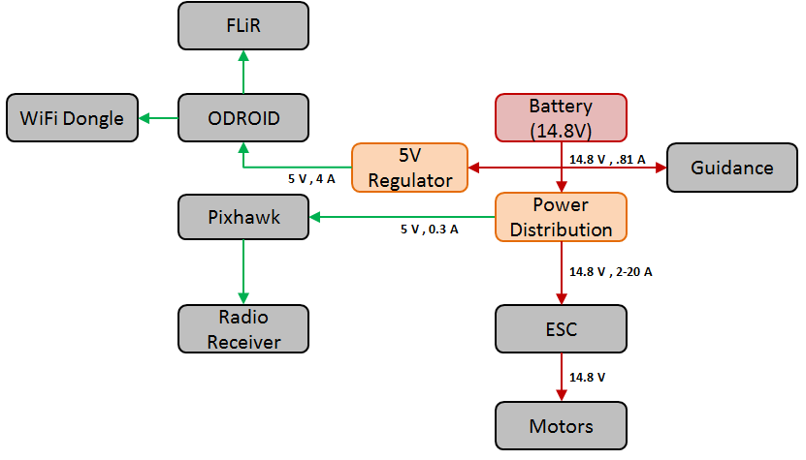

Figure 5: Electrical FBD

A 14.8 V (4S) battery was selected to power the Terminator system. More information on the battery is provided in the next subsection when the power balance is covered. The line coming off the battery is split in three directions. First it goes connects to the Guidance sensor using an XT60 connector. Second it connects to a 5V UBEC which regulates the voltage to 5 V needed by the ODROID. The ODROID then powers the Wi-Fi dongle and the FLiR Lepton camera, both at 5 V. The third path coming off of the battery leads to a power distribution board, Figure 6.

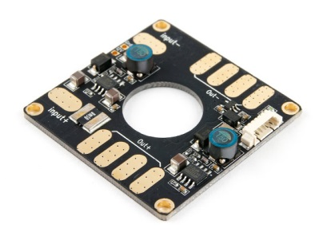

**Pixhawk 6-wire power cable connector**

Figure 6: Power Distribution Board

The power distribution board (PDB) then divides the 14.8 V to the four motors via the speed controllers. The nice addition to this PDB is that it also contains a 5V UBEC and a connector for the 6-wire cable needed to power the Pixhawk autopilot board. The Pixhawk then powers the radio receiver.

## Power Budget & Flight Endurance

Using the laid the FBD (Figure 5) and the current and voltage draws found for each of the components a power budget was determined, given in Table 4. Notice from this table that only four of the components are shown. This is because the ODROID powers the FLiR and Wi-Fi dongle and the Pixhawk gives power to the radio receiver. As software development is still underway exact current draws are unknown for some of the components. Values for items such as Guidance and ODROID were taken at their maximum values to give an upper bound to the estimation.

Table 4: Terminator Quadcopter Power Budget

|  |  |  |  |  |
| --- | --- | --- | --- | --- |
| **Component** | **Qty** | **Nominal Voltage [V]** | **Current Draw**  **[mA]** | **Power Consumption**  **[mW]** |
| ODROID XU4 (powers FLiR & Wi-Fi) | 1 | 5 | 4000 | 20000 |
| DJI Guidance Sensor | 1 | 14.8 | 810 | 12000 |
| Pixhawk (powers radio receiver) | 1 | 5 | 300 | 1500 |
| SunnySky V2216-12 II Motors* | 4 | 14.8 | 4730 | 70017 |
| **Total** | | | **24030** | **313568** |

*current and power are calculated for hover conditions

To no surprise the motors consume the most amount of power, around 89.3% of the total power consumption and 78.7% of the total current draw. Current draw and power consumption were found for the motors during the hovering condition. This is the best way to estimate their usage as the quadcopter will be hovering or flying relatively close to this condition for most of its mission. It is also the best estimate available as the mass of the system has already been calculated. Using the experimental data given in Table 3, a best fit curve was created for the data in order to extrapolate various current draws of the motor based on the thrust needed. Figure 7 shows the graph for the experimental data. A quadratic function was fit to the data points giving Equation 1 with the coefficients given in Table 5.

|  |  |
| --- | --- |
| $$I=a^{2}T*bT+c$$ | (1) |

Table 5: Function Coefficients for Equation 1

|  |  |
| --- | --- |
| **a** | 4.72E-06 |
| **b** | 8.50E-03 |
| **c** | -1.947 |

Using the total mass of the system and setting that as the thrust in Equation 1, it was determined that each motor would draw around 4.73 A or 70 W.

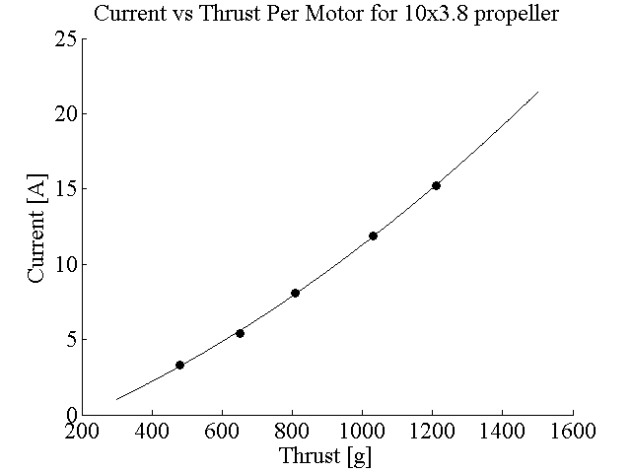

Figure 7: Experimental Current Thrust Curve for SunnySky Motors

To estimate expected flight endurance the total current draw of 24000 mA was used. Using a 10000 mAh LiPo battery, drained to 80% of its total capacity, for LiPo safety, the Terminator quadcopter should be able to fly for around 20 minutes with no payload. This exceeds the minimum flight duration of 10 minutes set forth in the requirements.

Another customer requirement is for the system to be able to hold additional payload. Given this requirement, a payload vs. duration graph was created to get the applicable design space, Figure 8.

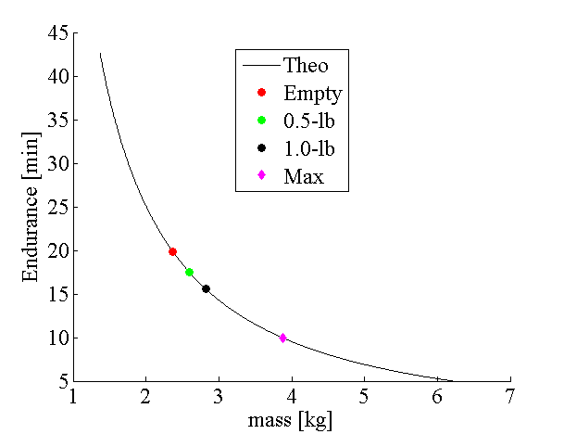

Figure 8: Payload vs. Endurance Chat for 2.37 kg Empty Mass Quadcopter

Shown on the graph is the expected no-payload condition. Payloads of 0.23 kg (0.5 lb) and 0.45 kg (1 lb) are also shown on the graph, estimated at 17.5 and 15.6 minutes respectively. The maximum payload that could theoretically be carried and still make the 10 minute requirement is 1.5 kg.

# Stopping Distance Simulation

A quick simulation was performed in order to determine the distance needed by the quadcopter to stop given a set velocity. Using the limitations of the Guidance sensor and a simple model of the quadcopter performance, the maximum flying speed of the quadcopter can be determined.

The assumptions that went in to this analysis are as follows:

* The quadcopter is limited to $±30°$ in pitch rotation
* 1-Dimensional Motion (No-Lateral movement, Quadcopter is expected to maintain altitude)
* Drag forces are ignored
* Simple kinematic equations are acceptable
* During the transition stage from pitched forward to pitched backward the forward velocity does not change

The simulation begins with the quadcopter moving forward at an initial velocity v0 and time t0. At time t0 it begins to rotate from its initial pitch of 30° to -30° maintaining the same velocity. Once it reaches its final pitch angle the thrust in the opposite direction of motion slows the quadcopter down. Estimates of the moments of inertia are given in Table 6. For this analysis, only the Iz moment of inertia is needed as this affects the pitch.

Table 6: Terminator Estimated Moments of Inertia

|  |  |
| --- | --- |
| **Ix** | 0.0268 kg m2 |
| **Iy** | 0.0191 kg m2 |
| **Iz** | 0.0290 kg m2 |

A free body diagram is given in Figure 9. The motors at each end put out double the force to account for the symmetry of the quadcopter.

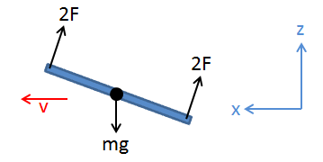

Figure 9: Free Body Diagram of Stopping Simulation

Summing the forces in the x and z directions allows for the deceleration to be calculated. This can be done as the lift must equal the weight, and any reserve force is applied to stop the vehicle in the x direction. The x-acceleration is given by Equation 2, where theta is the angle from the x-axis, or maximum pitch of the quadcopter, and g is the acceleration due to gravity.

|  |  |
| --- | --- |
| $$a_{x}=-g\tan{θ}$$ | (2) |

Knowing this acceleration the time and distance to stop can be calculated using Equations 3 and 4 respectively.

|  |  |
| --- | --- |
| $$t_{s}=\frac{-v_{0}}{a_{x}}$$ | (3) |
| $$d=\frac{-v_{0}^{2}}{2a_{x}}$$ | (4) |

The time for the quadcopter to rotate the 60° is given by Equation 5. Here the variable L is the length from the center of rotation to the end of the quad were the motors are (7 inches). The distance traveled during this time period is given by Equation 6.

|  |  |
| --- | --- |
| $$t_{rot}=\frac{∆θ I_{z}^{2}}{2{ F}^{2 }L^{2}}$$ | (5) |
| $$d_{rot}=v_{0}t_{rot}$$ | (6) |

The total time it then takes to stop is given by the sum of Equations 3 and 5. Similarly, the total distance is given by the sum of Equations 4 and 6. Evaluating these equations for various initial velocities gives the plot shown in Figure 10. For now ignore the red and blue line, these are the constraints due to the sensors, which is covered next.

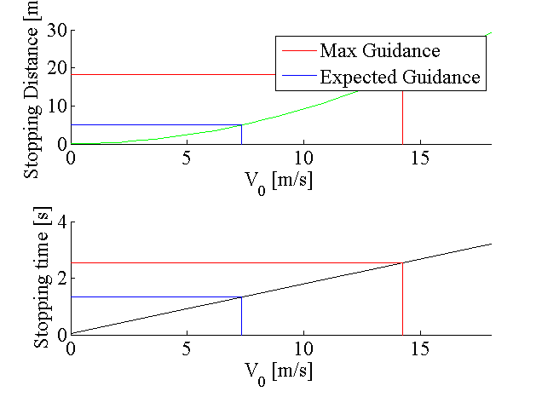

Figure 10: Stopping Simulation Results

Mapping and obstacle detection is performed using the ultrasonics and images from the stereo cameras on the Guidance sensor. The limitations of it will limit the performance of the vehicle by the depth at which it can detect obstacles. The specifications as specified by the manufacturer are given in Table 7. Note that at this time verification of these specifications has not been performed and will be used as declared here. Given these values a theoretical maximum distance can be found at which Guidance can detect an object. This was found to be 18.35 m.

Table 7: Guidance Specifications

|  |  |
| --- | --- |
| **sensor range** | 0.2-20 m |
| **position accuracy** | 0.05 m |
| **velocity range** | 0-16 m/s |
| **velocity accuracy** | 0.04 m/s |

Using this distance will provide an absolute upper bound on the system as to how fast it can fly and still come to a stop before hitting the obstacle. Using this value and subtracting the distance traveled during rotation gives the actual stopping distance which can be substituted for d in Equation 4. Solving for and taking the positive root of this equation gives the maximum velocity. This is shown by the red lines in Figure 10. This leads to a maximum flight velocity of 14 m/s. If the actual performance of Guidance is limited to 5 m of resolution, then the solution provides the blue lines in Figure 10. This gives a maximum velocity of 7 m/s.